Mizoram University

Procedure for Preparation of Course Outcome (CO) and Program Outcome (PO)Attainment

Programme Outcomes (PO)

POs are statements about the knowledge and skills the graduate/post graduate of an institution should have. POs deal with the general aspect of Graduation/Post Graduation for a particular programme, and the competencies and expertise a graduate/post graduate will possess after completion of the program. These are broad and cover a wider area than of COs.

Programme Specific Outcomes (PSO)

Programme Specific Outcomes (PSOs) are specifically defined outcomes of the programme which the graduates have to acquire by the end of the programme.

Course Outcome (CO)

They are the resultant knowledge skills the student acquires at the end of a course. It defines the cognitive processes a course provides. It is the statement which indicates, that a student can do after the successful completion of a course. Every Course leads to some Course Outcomes. The CO statements are defined by considering the course content covered in each module of a course. For every course, teacher may prepare six or less course outcomes.

The Mizoram University follows the below mentioned structural way to obtain the CO and PO for different programs and courses offered. The Flow Chart is depicted below:
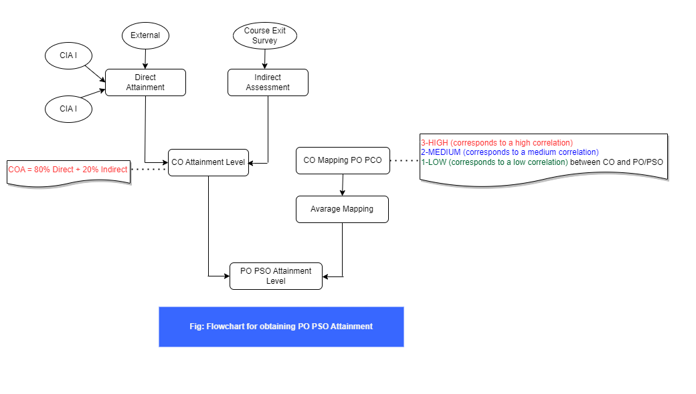

The step-wise procedure is detailed as given below with a simple example:

1: Details of the courses (course name, course code, total student number, semester etc.).

COURSE CODE: 21CEPC391
COURSE NAME: Data Structures & Algorithm Laboratory) [2nd year, 3rd semester]
Course Prerequisite: Programming using elementary features of C.
Course Objective: Imparting basic concepts of data structures and algorithms

2: Outline of Course Outcomes (COs):
Course outcomes:
- CO1: Ability to develop skills for designing simple linear and nonlinear data structures
- CO2: Ability to understand a systematic approach to organizing, writing and debugging C programs
- CO3: Ability to solve problems implementing appropriate data structures
- CO4: Ability to implement sorting and searching algorithms using relevant data structures

3: Outline the Program Outcomes (PO) and Program Specific Outcomes (PSO). Perform the CO mapping with PO and PSO, as illustratively shown in the table.

Program Specific Outcomes (PSO) |  | Program Outcomes (PO)
PSO1: Insight into various Fields of Information Technology  PSO2: Understand and resolve Engineering Problems  PSO3: Ready for Industry, Academics and Research |  | PO1: Engineering Knowledge
 |  | PO2: Problem Analysis
 |  | PO3: Development of solutions
 |  | PO4: Investigation of Complex Problems
 |  | PO5: Modern Tool Usage
 |  | PO6: The Engineer and society
 |  | PO7: Environment and Sustainability
 |  | PO8: Ethics
 |  | PO9: Individual and Team work
 |  | PO10: Communication
 |  | PO11: Project Management and Finance
 |  | PO12: Life-long learning

4: Perform the CO mapping with PO and PSO, as shown in the table.

CO Mapping with PO and PSO
CO | PO1 | PO2 | PO3 | PO4 | PO5 | PO6 | PO7 | PO8 | PO9 | PO10 | PO11 | PO12 | PSO1 | PSO2 | PSO3
CO1 | 2 | 2 | 2 |  |  |  |  |  |  |  | 2 | 2 | 3 | 2 | 2
CO2 | 2 | 2 | 2 | 2 | 1 |  | 1 |  |  |  | 2 | 2 | 3 | 3 | 2
CO3 | 2 | 2 | 2 | 2 | 2 |  |  |  |  |  | 2 | 2 | 3 | 2 | 3
CO4 | 3 | 3 | 3 | 3 |  | 1 | 1 | 1 | 1 | 1 | 2 | 2 | 3 | 3 | 2
Average | 2.25 | 2.25 | 2.25 | 1.75 | 0.75 | 0.25 | 0.5 | 0.25 | 0.25 | 0.25 | 2 | 2 | 3 | 2.5 | 2.25
3-High 2-Medium 1-Low

Here in the table, ‘3’ corresponds to a high correlation; ‘2’ corresponds to a medium correlation, and ‘1’ corresponds to a low correlation, between CO and PO/PSO.

5: Fill in the entries (bold) as suggested in the table for CO attainment calculations.

Teacher-in-charge may use more internal assessment tools (assignments/quiz/presentation, etc.).
The target (P) is 60% (first division) or as per the requirements of the course and program. Further, the target remains same for direct and indirect assessments
CO ATTAINMENT CALCULATION
 | Direct Assessment |  |  |  |  |  |  |  | Indirect Assessment
 | Internal |  |  |  |  |  | External
 | C1 |  | C2 |  |  |  | ESE |  | Course Exit Survey
Number of students who have scored more than the target (P)  (Target is 60%) |  | P |  | P |  |  |  | P
Percentage of students who have achieved the target = (P/N)x100  (N is the number of students who appeared in  the exam) |  | (P/N)x100 |  | (P/N)x100 |  |  |  | (P/N)x100 |  | (P/N)x100
Attainment Level  (3 for ≥80, 2 for ≥70 %, 1 for ≥60, 0 for <60%) | a = |  | b = |  |  |  | c= |  | d=
Attainment based on internal assessment (CIA) = Average of (a and b); |  |  |  |  | CIA | =
Direct CO Attainment Level (DA) =40%CIA + 60% End-Term (c) ; |  |  |  |  | DA | =
Indirect CO Attainment Level (IA) (based on Exit Survey (d)); |  |  |  |  | IA | =
80 % of DA
20 % IA
CO Attainment Level (COA) = 80 % DA+ 20 % IA; |  |  |  |  | COA | =

6: After filling the details in the last step (P and P/N), assign the attainment levels (3/2/1 according to (P/N) values) based on Direct Assessment 1, Direct Assessment 2, and Indirect Assessment.

Attainment levels

(3 if more than 80% of students achieved the target / 2 for >70% to 80%and / 1 for>60% to 70%)
Level | Percentage achieved by students
3 | ≥80
2 | ≥70 to <80%
1 | ≥60 to <70%
0 | <60%

Direct assessment 1: refers to evaluation through internal assessments, which include Continuous Internal Assessments (C1 and C2) in terms of Internal Assessment Tests, Lab. Assignments, Home Assignments, Class/Assignment Tests, Presentations, quizzes, etc.
Direct assessment 2: refers to evaluation through End Semester Examination (ESE)

Indirect assessment: refers to the exit feedback survey taken by students/faculty/employers. The exit feedback survey is to be taken up after the end of the semester examination. The exit survey is based on a marking scheme (1-3) for each CO.
- The course exit survey samples are given below for student/faculty/employer
(Note the respective course-in-charge may modify these templates according to the requirements of the course)

Sample1: Course Outcome exit survey for students

Course Outcome |  | 0 (Very Low) | 1(Low) | 2(Moderate) | 3(High)
CO1 | Ability to develop skills for designing simple linear and nonlinear data structures
CO2 | Ability to understand a systematic approach to organizing, writing and debugging C programs
CO3 | Ability to solve problems implementing appropriate data structures
CO4 | Ability to implement sorting and searching algorithms using relevant data structures

Sample 2: Course Contents exit survey for students.

Questions | 0 (Very Low) | 1(Low) | 2(Moderate) | 3(High)
Quality of the Course Content
Relevance of the textbook to this course
Were the lectures clear/well organized and presented at a reasonable pace?
Did the lectures stimulate you intellectually?
Are the assignment/lab experiment procedures clearly explained?

Sample3: Faculty/Employer Survey

Questions | 0 (Very Low) | 1(Low) | 2(Moderate) | 3(High)
Satisfaction with the caliber of the graduates
Courses are relevant to the organization’s vision and mission
Satisfaction with the speed at which course content is being adapted to meet changing industrial needs
Relevant subject or discipline knowledge
Quality of employability skills and attributes
The satisfaction that graduates are learning the right skills

Further steps to follow for the calculation of Course Outcome attainment (COA) level:

Please refer to the first column in the table (in orange) for conventions used (A, B, C, D, and E) for each parameter to calculate COA.
A: Assign the attainment levels (3 for≥80%; 2 for ≥70 to <80%;1 for≥60 to <70%) for Direct Assessment 1, Direct Assessment 2, and Indirect Assessment.
B: Attainment based on internal assessment (CIA) = Average of [C1(a) andC2(b)]
C: Direct CO Attainment Level (DA) =40%CIA + 60% End-Semester Examination (c)

D: Indirect CO Attainment Level (IA)

E: Finally, Course Outcome Attainment (COA) level = 80% of DA and 20% of IA

 |  | Direct Assessment
 |  | Direct Assessment 1 (Internal; CIA) |  |  |  |  |  | Direct Assessment 2 (ESE)
 |  | C1 |  | C2 |  |  |  | ESE |  | Course Exit Survey
 | Number of students who have scored more than the target (P)  (Target is 60%) |  | 19 |  | 15 |  |  |  | 22 |  | 18
 | Percentage of students who have achieved the target = (P/N)x100  (N is the number of students who appeared in  the exam) | 25 | 76 | 25 | 60 |  |  | 25 | 80 | 25 | 72
A | Attainment Level  (3 for >80%, 2 for >70%, 1 for> 60%) | a = | 2 | b = | 1 |  |  | c= | 2 | d= | 2
B | Attainment based on internal assessment (CIA) = Average of (a and b); |  |  |  |  | CIA | = | 1.5
C | Direct CO Attainment Level (DA) =40%CIA + 60% End-Semester (c) ; |  |  |  |  | DA | = | 1.8 | = 0.4x1.5+0.6x2=1.8
D | Indirect CO Attainment Level (IA) (based on Exit Survey (d)); |  |  |  |  | IA | = | 2
 | 80 % of DA |  |  |  |  |  | = | 1.44
 | 20 % IA |  |  |  |  |  | = | 0.4
E | CO Attainment Level (COA) = 80% DA + 20% IA |  |  |  |  |  | = | 1.84

7: Based on the Course Objectives Attainment (COA) value as calculated at the end of step 6, perform the PO/PSO Attainment Calculations as shown below:

PO/PSO Attainment= COA x M/3 (Refer to Step 6 for COA value)

CO | PO1 | PO2 | PO3 | PO4 | PO5 | PO6 | PO7 | PO8 | PO9 | PO10 | PO11 | PO12 | PSO1 | PSO2 | PSO3
CO1 | 2 | 2 | 2 |  |  |  |  |  |  |  | 2 | 2 | 3 | 2 | 2
CO2 | 2 | 2 | 2 | 2 | 1 |  | 1 |  |  |  | 2 | 2 | 3 | 3 | 2
CO3 | 2 | 2 | 2 | 2 | 2 |  |  |  |  |  | 2 | 2 | 3 | 2 | 3
CO4 | 3 | 3 | 3 | 3 |  | 1 | 1 | 1 | 1 | 1 | 2 | 2 | 3 | 3 | 2
Average | 2.25 | 2.25 | 2.25 | 1.75 | 0.75 | 0.25 | 0.5 | 0.25 | 0.25 | 0.25 | 2 | 2 | 3 | 2.5 | 2.25

PO Attainment Calculations
 | PO1 | PO2 | PO3 | PO4 | PO5 | PO6 | PO7 | PO8 | PO9 | PO10 | PO11 | PO12 | PSO1 | PSO2 | PSO3
Average Mapping (M) | 2.25 | 2.25 | 2.25 | 1.75 | 0.75 | 0.25 | 0.5 | 0.25 | 0.25 | 0.25 | 2 | 2 | 3 | 2.5 | 2.25
PO / PSO  Attainment Level* | 1.38 | 1.38 | 1.38 | 1.07 | 0.46 | 0.15 | 0.30 | 0.15 | 0.15 | 0.15 | 1.22 | 1.22 | 1.84 | 1.53 | 1.38
* = COA x M/3 (Refer to Step 6 for COA value)

