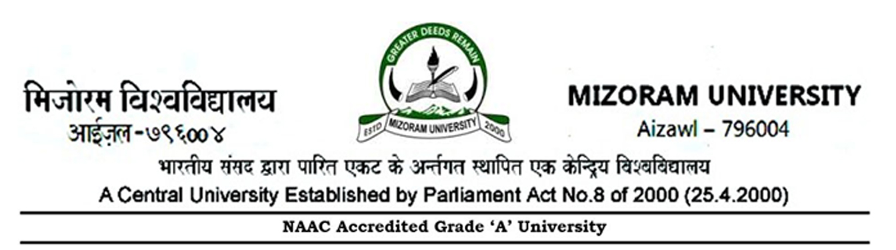

No: 5-33/Estt.I/12/161 Dated Aizawl, the 19th May, 2023
NOTIFICATION
On expiry of the existing term of the Students’ Grievance Redressal Committee and in terms of Mizoram University Ordinance OE-11(3)(A), the Vice Chancellor, Mizoram University is pleased to re-constitute the Committee for a term of two years w.e.f. 19th May, 2023 or until further order whichever is earlier, as follows :

Chairperson & Convener :
Prof. Prof. John Zothanzama, Deptt. of Biotechnology, MZU

Two representatives of Students Council :
President, MZUSC
General Secretary, MZUSC

Four nominees of the Vice Chancellor from amongst the teachers :
Prof. Linda Zohmingliani, Deptt. of Education
Dr. K.C.Lalmalsawmzauva, Deptt. of Geography & RM
Prof. Manoj Kumar Verma, Deptt. of Library & Information Sc.
Dr. Ningthoujam Irina Devi, Deptt. of Public Administration

Special Invitee : Dean of the concerned School
Special Invitee : Head of the concerned Department

Member Secretary : Dean, Students’ Welfare

(Dr.R.Zonuntluanga)
Joint Registrar (Estt.)
Copy to :-
- P.S. to the Vice Chancellor, Mizoram University for information.
- P.S. to the Registrar, Mizoram University for information.
- P.S. to the Finance Officer, Mizoram University for information.
- P.A. to Librarian / CoE / Director-CDC, MZU.
- All Deans of School, Mizoram University.
- All Heads of Academic Departments, Mizoram University.
- President, MZUSC, Mizoram University.
- All members of the Committee.
- Personal File of concerned teachers / staff.

(Dr.R.Zonuntluanga)
Joint Registrar (Estt.)

