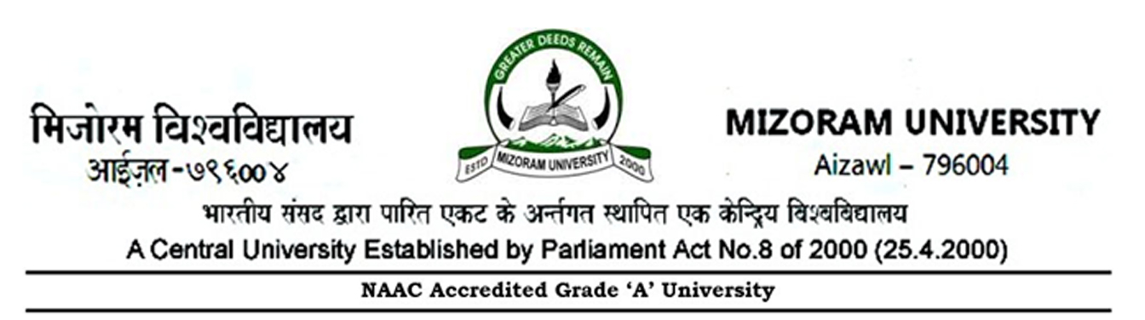

No: 5-33/Estt.I/12/160 Dated Aizawl, the 19th May, 2023

NOTIFICATION
On expiry of the existing term of the Non-Teaching Grievance Redressal Committee and in terms of Mizoram University Ordinance OE-11(3)(C), the Vice Chancellor, Mizoram University is pleased to re-constitute the Committee for a term of two years w.e.f. 19th May, 2023 or until further order whichever is earlier, as follows :

Chairperson & Convener :
Prof. Lalnundanga, Registrar, Mizoram University

Five persons from the non-teaching staff representing Women, Minority, SC, ST, OBC :
Representative of Women : Smt.Lalfakkimi, Assistant Registrar
Representative of Minority : Smt. Lalrinkimi Tochhawng, Section Officer
Representative of SC : Shri Pulak Das, Section Officer
Representative of ST : Dr.R.Zonuntluanga, Joint Registrar
Representative of OBC : Shri Lourembam Suraj Singh, System Analyst.

Head of the Section concerned : Member
(Dr.R.Zonuntluanga)
Joint Registrar (Estt.)
Copy to :-
- P.S. to the Vice Chancellor, Mizoram University for information.
- P.S. to the Registrar, Mizoram University for information.
- P.S. to the Finance Officer, Mizoram University for information.
- P.A. to Librarian / CoE / Director-CDC, MZU.
- All Deans of School, Mizoram University.
- All Heads of Academic Departments, Mizoram University.
- President, MUNTSA, Mizoram University.
- All members of the Committee.
- Personal File of concerned teachers.

(Dr.R.Zonuntluanga)
Joint Registrar (Estt.)

