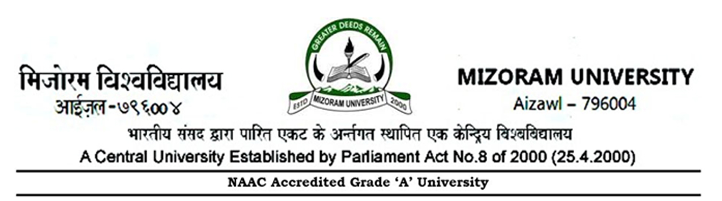

No: 5-33/Estt.I/12/158 Dated Aizawl, the 19th May, 2023

NOTIFICATION

The Vice Chancellor, Mizoram University is pleased to appoint Prof. Thangchungnunga, Retired Professor, Deptt. of Economics, Chawlhhmun, Aizawl as Ombudsperson in Students Grievances Redressal Committee for a period of 3(three) years with immediate effect or until further order whichever is earlier.

(Dr.R.Zonuntluanga)
Joint Registrar (Estt.)
Copy to :-
- P.S. to the Vice Chancellor, Mizoram University for information.
- P.S. to the Registrar, Mizoram University for information.
- P.S. to the Finance Officer, Mizoram University for information.
- P.A. to Librarian / CoE / Director-CDC, MZU.
- All Deans of School, Mizoram University.
- All Heads of Academic Departments, Mizoram University.
- President, MZUSC, Mizoram University.
- Principal, Pachhunga University College.
- Concerned persons for information and necessary action.

(Dr.R.Zonuntluanga)
Joint Registrar (Estt.)

