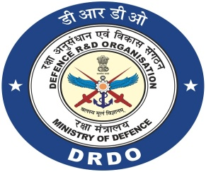 | DRDO-Industry-Academia  Centre of Excellence (DIA-COE)  Mizoram University, Tanhril Aizawl-796004

Prof. Diwakar Tiwari Email : director.nestc.mzu@gmail.com
Director Mobile : +91-9862323015

F. No: 4/2022/DIA-COE/5 Dated Aizawl, the 30th June, 2022

Sub.: DIA-COE, Mizoram University, Aizawl
Re.: Second Call for Concept Note Submission under various Research Verticals

Dear Sir/Madam,

Greetings from DRDO-Industry-Academic- Centre of Excellence, MZU, Aizawl

The DIA-COE, Mizoram University is established with full support from DRDO, Govt. of India with the objective to facilitate the collaboration between the DRDO Research Laboratories and North Eastern Institutes/Universities and start-ups/industry to formulate and achieve specific research outcomes/products for the defence personnel or the society in general. The DIA-COE, Mizoram University has already identified the research verticals as mentioned below.

(a) Management of Agro-bio resources
(b) Environment & waste management
(c) Post-harvest management
(d) MEMS based Sensor for specific applications
(e) Advanced electromagnetics & high frequency electronics design system

In addition to above mentioned broad area of work, DRDO is looking for some specific requirements in some of the research verticals (enclosure). The interested faculty members are suggested to submit the concept note in association with MZU faculties under the verticals mentioned in the prescribed format latest by 20.07.2022 preferably by email (director.nestc.mzu@gmail.com).

The concept notes will be evaluated/screened by the DRDO Stake holding Research Laboratories and selected/recommended proposals will be invited for presentation and possible support. It is worth mentioning that Secretary DD (R&D) and Chairman DRDO, suggested to create greater network within all the NE Institutions by collaborating the intuitions through the program.

Therefore, I request you to kindly disseminate the information to your University / Institution / Colleges for its wide publicity for maximum outreach and greater outcome.

With warm regards,

Yours sincerely,
(Diwakar Tiwari)
Encl/-
1. Subject area identified by DRDO Labs
2. Format of concept proposal

