(A Central University under the Act of Parliament)

Department of Chemistry
(A DST-FIST Supported Department)
School of Physical Sciences
Dr. Diwakar Tiwari  Professor | Dated: 25.02.2022

File No.: 1/MZUCHEM/DT/DRDOProj/DRDO/2019/01

ADVERTISEMENT FOR THE POST OF JRF

Applications are invited from the Indian Nationals for filling of ONE position of Junior Research Fellow, in a DRDO, Govt. of India sponsored Research Project entitled, “Electrochemical sensor for the trace detection of arsenic (As), iron (Fe) and Fluoride” at the Department of Chemistry, Mizoram University, Aizawl-796004. The position is fully temporary and is co-terminus with the project for about 18 months having the emoluments of Rs. 31,000/pm.

Eligibility: The applicant should have qualification M.Sc. in Chemistry/Environmental Science or M.Tech. (Environmental/Chemical Engineering). Applicants having NET/GATE qualification will be given preference in selection.
Age Limit: The age limit to apply for the position is below 28 years. The upper age limit relaxation along with the preference to the SC/ST/OBC will be given as per the GOI norms.

Applicants are suggested to send their complete Bio-data to the undersigned (preferably by E.mail: diwakarmzu@gmail.com) latest by 06.03.2022.
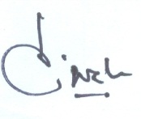
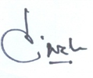
(Diwakar Tiwari)
Principal Investigator

